A Hybrid Econometric–Machine Learning Approach for Short-Horizon Stock Direction Prediction with Economic Evaluation

Abstract

This study develops a hybrid econometric-machine learning framework for short-horizon stock price direction prediction using high-frequency market data. Unlike conventional approaches that primarily focus on predictive accuracy, this work emphasizes the economic value of weak predictive signals in noisy financial environments. The proposed approach integrates econometric models, technical indicators, and gradient boosting methods to capture both linear temporal dependencies and nonlinear market patterns. Historical price data at five-minute intervals from five large-cap NYSE stocks, spanning January 2021 to December 2024, are used for model development and evaluation. Econometric models, including ARMA and GARCH, are employed to estimate return and volatility forecasts, while technical indicators are incorporated as predictive features. These features are combined with lagged returns and temporal seasonality variables and used to train an XGBoost classifier to predict the direction of price movement in the next five-minute interval.
The model achieves a test accuracy of 51.38% and a ROC-AUC score of 0.53, indicating a modest but consistent predictive edge over random guessing in a highly noisy financial environment. To assess practical applicability, a trading strategy based on probability thresholding is implemented and evaluated using economic metrics. By selectively executing high-confidence predictions, the framework converts small statistical edges into economically meaningful outcomes. Walk-forward out-of-sample testing across eleven monthly windows shows a small but persistent positive trading edge with a median Sharpe ratio of 0.84 and stable drawdown characteristics. The results highlight that in high-frequency financial markets, predictive models should be evaluated as probabilistic ranking systems. This study demonstrates that hybrid econometric–machine learning approaches, when combined with disciplined trade selection, can yield persistent trading signals despite weak standalone predictive power.
Keywords: Stock Price Direction Prediction, Economic Evaluation, Econometric Models, Technical Indicators, High-Frequency, Machine Learning, NYSE

- Introduction

Recognizing and understanding patterns in stock prices is key for a trader to formulate their strategies. Forecasting future market trends has always been a challenge due to the high noise, nonlinearity, and other non-parametric properties of the stock data (Su et al., 2024). Many traditional approaches using statistical and econometric methods have been applied to better model market dynamics and make better investment decisions. Some of the traditional models include the Autoregressive (AR) model, the Moving Average (MA) model, and the Vector Autoregression (VAR) model. This suite of methods relies on a few assumptions concerning linearity, stationarity, and normal distribution of the data (Shah et al., 2019). However, these models have revealed their inability to capture non-linear data, and their sensitivity to noise leads to overfitting historical data.

In the past 20-30 years, with the advent of advanced machine learning models, techniques used for financial forecasting have become increasingly complicated but reliable. With rapid advancements in algorithms and big data, research has increasingly shifted from econometric models towards machine learning (ML), deep learning (DL), and alternative data sources (Bao et al., 2025). Models like random forest and extreme gradient boosting (XGBoost), as well as deep neural networks, have made predictions more accurate and useful for the real world. Machine learning techniques have allowed the models to capture the non-linear patterns in the data, which was not possible using the traditional econometric methods (López De Prado, 2019). A more powerful forecasting method is combining the econometric as well as the machine learning models to capture both the linear and non-linear patterns of the data (Stempień & Ślepaczuk, 2025).

Technical indicators like Moving Average Convergence Divergence (MACD), Relative Strength Index (RSI), Exponential Moving Average (EMA), etc., can also offer significant insights into the market trends and support forecasting (Kah Him & Ching Pang, 2023; Khaidem et al., 2016).

This study systematically develops a model which combines the power of technical indicators, econometric models like the Autoregressive Moving Average Model (ARMA) and Generalized Autoregressive Conditional Heteroskedasticity Model (GARCH), as well as the XGBoost model, to predict the direction of short-horizon stock price movements. Rather than forecasting the stock price levels, the model focuses on directional prediction, which directly affects decision-making. The predictive signals are evaluated using trading-based performance metrics, enabling the assessment of their practical application in a realistic trading setting.

The next section provides a detailed review of existing literature in this context and identifies the gaps. The third section focuses on the methodology of the study. The fourth section summarizes the results of the data analysis and their interpretations. The final section provides a conclusion of the findings, implications of the study, limitations and directions for future research.

- Literature Review

2.1 Traditional and Machine learning models

In the early 2000s, Kim applied “black box” classifiers like Support Vector Machine for stock market prediction (Kim, 2003). It is an algorithm that is primarily used for classification by finding an optimal separating hyperplane between different data classes. This was the first wave of machine learning beyond linear predictors applied to financial forecasting. However, due to the stock market being inherently volatile and noisy, Support Vector Machines can be sensitive to this noise, which can negatively impact their performance. With advancements in machine learning algorithms, more complex models like Artificial Neural Networks emerged. Egeli et al. applied Artificial Neural Networks to forecast Istanbul Stock Exchange (ISE) market index values, with the network architecture being the Multi-Layer Perceptron and Generalized Feed Forward network (Egeli et al., 2003). This provided better accuracy than the standard Support Vector Machines. Latrisha et al. reviewed 30 studies in stock market prediction using machine learning techniques (Mintarya et al., 2023). They found out that Neural Networks (NN) have been the most often used ML approach for stock market prediction, proving the ability of NNs in forecasting stock prices. But still, the tendency of Neural Networks to overfit on historical data and learn noise may lead them to fail in new market conditions. William et al. carried out a comparative study of three prominent time-series models, such as Long Short-Term Memory (LSTM), Gated Recurrent Unit (GRU) and eXtreme Gradient Boosting (XGBoost). They reported that XGBoost achieved competitive or superior performance compared with GRU and LSTM in their experimental setup (William et al., 2025). The high performance of XGBoost shows its strength in capturing non-linear relationships within financial time-series data. LSTM can be highly effective for time series data due to its capability of learning long-term non-linear dependencies within sequential data. The relatively lower performance of GRU can be attributed to its simplified gating structure, limiting its ability to capture long term dependencies. Ni et al. compared the results of stock market prediction of various machine learning algorithms like linear regression, Support Vector Machine and LSTM with the econometric models like ARIMA and Fama-French Factor model (Ni & Chen, 2022). Their results showed that the combination of machine learning models and econometric models gave the best performance. Problems like overfitting and lack of interpretability have encouraged researchers to incorporate other technical indicators and complementary information sources.

2.2 Hybrid Models

Many hybrid models were proposed, which combined the traditional econometric models with the modern machine learning algorithms. Hybrid models could easily capture both the linear trends and nonlinear dependencies of the dataset. Wei et al. proposed an ARIMA-GARCH-LSTM hybrid model, where the ARIMA model is used to capture the linear trends, GARCH to express the residual volatility and the LSTM to capture the non-linear features (ChaoYan Wei et al., 2025). This hybrid model outperformed the individual ARIMA, GARCH and LSTM models and demonstrated adaptability during periods of high volatility.

Technical indicators are mathematical calculations to identify bullish or bearish behaviour of a stock. They use past stock prices and other data, such as volume, to estimate the trends. Kah et al. included technical indicators like Moving Averages (MA), Relative Strength Index (RSI), etc., with an LSTM model (Kah Him & Ching Pang, 2023). The results showed that the inclusion of technical indicators holds potential for enhancing the forecasting of stock prices. Earlier, Yang et al. proposed a LASSO-LSTM model that combined machine learning with technical indicators and financial sentiment analysis (Yang et al., 2022). This approach allowed them to incorporate news sentiment analysis with the technical indicators, but they didn’t include the econometric models, which may have affected their model’s capability to capture the linear patterns in the data.
The GARCH-based study demonstrates that traditional and extended GARCH models effectively capture volatility clustering and persistence, with strong empirical support such as high beta values and a strong correlation between predicted and actual volatility (Krishnan, 2010). The integration of machine learning techniques further enhances performance, reducing prediction errors. Similarly, the deep learning study proposes an autoregressive RNN/LSTM framework with technical indicators, showing superior predictive performance compared to traditional models like GARCH and ARIMA, and emphasizing the importance of modeling price prediction as a regression problem (Deng et al., 2020).
Across the studies, a key common finding is that hybrid approaches—combining statistical models with machine learning—yield better predictive accuracy than standalone techniques. Both streams also emphasize the importance of high-frequency data and temporal dependencies in improving forecasting outcomes (Celestin et al., 2025; Gu et al., 2020).
2.3 High-frequency data

High-frequency data has revolutionized stock market prediction by capturing intraday price, volume, and order book dynamics at sub-second intervals. Machine learning techniques dominate High-frequency data applications (Deng et al., 2020; Lanbouri & Achchab, 2020a). High-frequency data improves volatility forecasting by providing precise realized measures, revealing persistence and microstructure effects absent in daily data. It boosts market efficiency and liquidity predictions while aiding sentiment-integrated models. Noise, microstructure distortions, and computational demands limit reliability, with risks of heightened volatility during stress. Recent surveys emphasize hybrid models combining high-frequency data for better generalization. High frequency data shifts prediction from rare low-frequency signals to pervasive ultra-short-term insights, though integration with robust feature selection remains key (Lanbouri & Achchab, 2020b; Zhang & Wang, 2019; Zhou et al., 2018)
Research on stock market prediction using high-frequency data is underexplored, as the role of High-frequency data models during market crashes, flash crashes, or high volatility remains unclear, with calls for comparative analyses across market regimes. Quantum machine learning and novel hybrid models for jumps/nonlinearity are nascent, with gaps in scalability for real-time HFD processing. Limited work exists on emerging sectors like FinTech, where high-frequency Random Forest models show promise but lack broader validation. Expensive High-frequency data storage/processing hinders adoption, and HFT competition's impact on liquidity/volatility needs more empirical dissection.
2.4 Research Gaps
Most of the studies on stock market prediction discussed above report improvements in predictive accuracy through the use of hybrid models. However, several important gaps remain in the existing literature.
Firstly, only a limited number of studies examine whether improved predictive accuracy translates into economically meaningful trading performance. Evaluation metrics such as the Sharpe ratio, maximum drawdown, and profit factor are often overlooked. A predictive model can be considered truly valuable only if it yields consistent profitability under real trading conditions. Although some hybrid models have been proposed, they typically do not incorporate a comprehensive set of economic performance measures, which may significantly influence their practical effectiveness. These limitations underscore the need for models that integrate statistical rigour with machine learning capabilities.
Secondly, most existing studies rely on low-frequency (daily) data for developing prediction models. Such models have limited practical applicability, as trading decisions based on low-frequency data may not capture short-term market dynamics effectively. For predictive models to be practically useful, they should leverage high-frequency data and enable real-time analysis, thereby facilitating more actionable and timely trading decisions. Furthermore, high-frequency trading remains a challenging domain due to the substantial noise present in financial time series data. Recent advancements in financial machine learning, particularly the work of de Prado (2018), emphasize the importance of robust evaluation frameworks, advanced feature engineering, and the avoidance of overfitting when dealing with noisy financial datasets.
In light of these gaps, the present study proposes a unified framework that integrates econometric techniques, machine learning adaptability, and technical indicators to enhance prediction accuracy using high-frequency trading data in real time. Additionally, the study evaluates the economic performance of the proposed model to ensure its practical relevance and applicability.
- Methodology

3.1 Data Collection and Analysis
Given the objective of utilizing high-frequency data, this study employs intraday stock price data at 5-minute intervals. The dataset spans a period of 1,004 trading days, from 4 January 2021 to 30 December 2024, yielding approximately 100,000 observations per stock. Due to computational constraints, the analysis is limited to five stocks, resulting in a total dataset of 390,450 observations. To ensure representativeness and relevance, the selected stocks comprise some of the largest firms listed on the New York Stock Exchange (NYSE), based on market capitalization. Table 1 presents the selected stocks along with their respective sectors, market capitalization, and the rationale for their inclusion. Historical stock price data were obtained from Bloomberg. For each stock, the dataset includes open, high, low, close, and volume (OHLCV) variables, along with timestamps and corresponding ticker symbols, thereby enabling detailed intraday analysis.
Table 1: Description of the selected stocks
Symbol | Company’s name | Sector | Market Capitalization (Feb 2026) | Reasons to include
AAPL | Apple Inc. | Technology | $3.8 - $4.0 Trillion | High liquidity, benchmark
MSFT | Microsoft Corporation | Technology | $3.4 - $3.6 Trillion | Stable, different dynamics than AAPL
TSLA | Tesla Inc. | Consumer Cyclical | $1.4 - $1.5 Trillion | High volatility, news sensitive
JPM | JPMorgan Chase & Co. | Finance | ~$850 Billion | Different correlations
JNJ | Johnson & Johnson | Healthcare | ~$520 Billion | Low volatility, Defensive

To capture the temporal dependencies in the datawe have used two econometric models- ARMA and GARCH. The Auto Regressive Moving Average (ARMA) is a statistical tool for time series analysis that forecasts future values based on past values (AR part) and past forecast errors (MA Part). It is used to model data that is stationary, that is, its statistical properties don’t change over time. It has two parameters, p and q, which are the orders of the AR and MA part respectively. The ARMA(p,q) can be described as (1). The Generalized Auto Regressive Conditional Heteroskedasticity (GARCH) is a statistical tool used to forecast volatility in time series data. It is an extension of ARMA, assuming that the variance of the error term changes over time. The GARCH(p,q) can be described as (2).
$X_{t} = c + ϵ_{t} + \sum_{i=1}^{p}{ϕ_{i}X_{t-i}}+\sum_{j=1}^{q}{θ_{j}ϵ_{t-j}}$ (1)
$σ_{t}^{2}= ω+\sum_{q=1}^{q}{α_{t}ϵ_{t-i}^{2}}+\sum_{j=1}^{p}{β_{j}σ_{t-j}^{2}}$ (2)

The parameters p and q for both models were chosen as 1, which is usually sufficient for most financial applications. It provides a good balance between accuracy and complexity, avoiding overparameterization. We first trained the ARMA (1,1) and GARCH (1,1) on the training data, and then used the coefficients obtained to calculate the forecasted values for each timestamp.
A broad set of technical, statistical, and time-based indicators was initially calculated using the raw price data. From these, a compact set of informative features was chosen for the final XGBoost model to avoid redundancy and balance expressiveness and generalization. The final set of features used for training the XGBoost model is summarized in Table 2.
Table 2: Final set of features used for training the XGBoost model
S.No. | Features | Indicators
1 | Stock symbol mapped to respective code
2 | Price and Return-based features | - Close Price  - Lagged returns – Percentage returns lagged by 1, 2, 3 and 6 periods  - Risk-adjusted returns – Returns normalized by recent volatility to account for market risk conditions
3 | Volatility and Forecast-based features | - Rolling volatility - Rolling standard deviation of returns over a 10-period window  - Volatility forecast - Volatility estimated using the GARCH model trained on past returns  - Return forecast - Returns forecasted using the ARMA model
4 | Trend and Regime Indicators | - EMA-based trend filters – Binary labels indicating medium-term (20/50 EMA) and long-term (200 EMA) trend regimes  - MACD signal – Derived from the MACD indicator to capture momentum shifts  - RSI timing indicator - Relative Strength Index (RSI) used as a bounded momentum oscillator
5 | Strategy Prior Signals | Long and short signals – Indicators derived from past price and indicator information, acting as weak priors for directional prediction
6 | Temporal and Seasonality Features | - Calendar features – Hour, day of week, month, quarter and year  - Cyclical encodings – Sine and cosine transformations of time features to capture periodicity

The whole dataset was split into three sets: training, validation, and testing. The details of each set are shown in Table 3.
Table 3: Details of Training, Validation and Testing datasets
Dataset | Start date | End date
Training set | 4th January 2021 | 11th September 2023
Validation set | 12th September 2023 | 28th December 2023
Testing set | 2nd January 2024 | 27th December 2024

3.2 Tools and Frameworks
Extreme Gradient Boosting (XGBoost) is a machine learning algorithm that is an extension of Gradient Boosting Decision Trees (GBDT). Under this algorithm, weak learners are added to minimize the errors, where each tree learns from the mistakes of the previous trees, to perform better (Ampomah et al., 2020). It uses a pool of classification and regression trees (CART), where the final prediction is the sum of the outputs of all the individual trees (Xu et al., 2022). It also includes a regularisation term in its loss function, which makes it effective on noisy data as well (Ampomah et al., 2020).
We trained the XGBoost Classifier model to predict the short-horizon directional movement, using log-loss as the evaluation metric, as shown in equation (3). Log-loss is generally used to evaluate the performance of probabilistic classifiers. The parameters used to build the model are shown in Table 4. The input features of the XGBoost model are the indicators listed earlier. The target variable of this model is the binary label indicating an increase/decrease in stock price in the next 5-minute interval. The target variable in the training dataset exhibits a near-balanced distribution, with 51.6% positive and 48.4% negative samples. This suggests the absence of class bias in the training data. To prevent overfitting, early stopping was implemented using the validation loss, configured to terminate training if the logloss on the validation set failed to improve for 50 consecutive boosting rounds. The training and validation log-loss curves for the XGBoost classifier are shown in Figure 1. The training loss decreases monotonically, while the validation loss stabilizes after an initial decline and does not show divergence. These curves show effective regularization and absence of overfitting, which is important for noisy financial time-series data.
$$LogLoss = -\frac{1}{N}\sum_{i = 1}^{N}{\left(y_{i} . log \left(p_{i}\right) + \left(1 - y_{i}\right) . log \left(1 - p_{i}\right) \right)} \left(3\right)$$
Table 4: Model Parameters
Parameter | Value
Max Depth | 8
N of trees | 800
Learning Rate | 0.01
Regularization lambda | 1.0
Regularization alpha | 0.3
Evaluation metric | Log loss
Early stopping rounds | 50

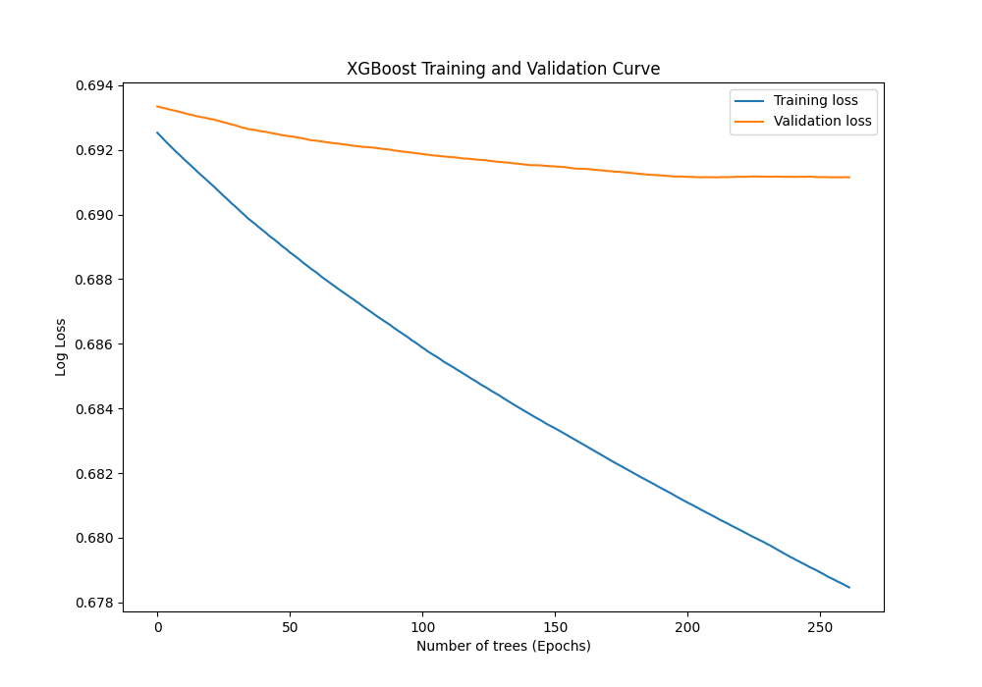
Figure 1: Training and Validation Curve
- Findings and Discussions

After training the model, we used the testing dataset to predict the closing prices and calculated the accuracy, precision, recall, F1 and ROC-AUC scores, as shown in Table 5.
Table 5: Test dataset results
Accuracy | 51.38%
Precision | 55.44%
Recall | 13.54%
F1-score | 21.67%
ROC-AUC | 52.94%

The accuracy on the test dataset was found to be 51.38%, which is slightly more than random. This is due to high levels of noise in the data, which makes it harder to predict the stock price movements. The low recall reflects the conservative nature of the probabilistic classifier. Rather than maximising the classification coverage, the model selectively identifies high-confidence signals. This is beneficial in trading, since high coverage may lead to reduced economic value.
Also, we run economic back testing to understand the economic implications of our model. At time t, the model predicts the probability of an upward price movement. If the probability is greater than the threshold value, then the trades are entered at the close of the subsequent bar and exited after a fixed holding period of h bars. These trades are then used to calculate trading metrics. The cost per trade was taken as $0.0002 per trade. While lower probability thresholds improve classification accuracy, they lead to low conviction trades, which have limited economic value. On the other hand, higher probability thresholds reduce coverage but improve risk-adjusted returns. Since our objective is to develop a profitable trading strategy, we use quantile-based thresholding on the training dataset. Thus, the threshold value chosen for testing as well as back testing was 0.515.
The net PnL was calculated for every trade whose probability was greater than the threshold, using equation (4).
$Net PnL = \frac{(exit price - entry price)}{entry price} - cost$ (4)
Where the entry price is the price at which the stock was bought, the exit price is the price at which the stock was sold (after h bars), and the cost is the transaction cost per trade, which was fixed as $0.0002.
The annualised per-trade Sharpe ratio was calculated using equation (5), where the risk-free rate was considered to be 0, which is common in intraday trading. Approximately 252 trading days were considered in a year, with each day having 78 bars.
$Sharpe =\frac{Mean(Net PnL per trade)}{Std(Net PnL per trade)} × \sqrt{\frac{252 × 78}{h}}$ (5)
The formula for total PnL is illustrated in equation (6).
$Total PnL = \sum_{i=1}^{N}{net PnL_{i}}$ (6)
Where N is the number of trades
We evaluate the model on multiple holding periods, ranging from 15 minutes to 70 minutes. Performance improves consistently with increasing horizon length, indicating that the model captures medium-term directional signals better than short-term noise. The horizon-wise performance of the XGBoost strategy, in terms of Sharpe ratio, Total PnL, Max Drawdown and Coverage, is shown in Figure 2. All the strategies are based on a fixed probability threshold, selected via Sharpe ratio optimization. As the horizon increases, the Sharpe ratio and Total PnL improve monotonically, while the trade coverage remains at an approximate constant of 12%. This indicates that the performance improvement is due to enhanced per-trade profitability, rather than increased trade frequency.
Figure 2: Horizon-wise performance of XGBoost trading strategy
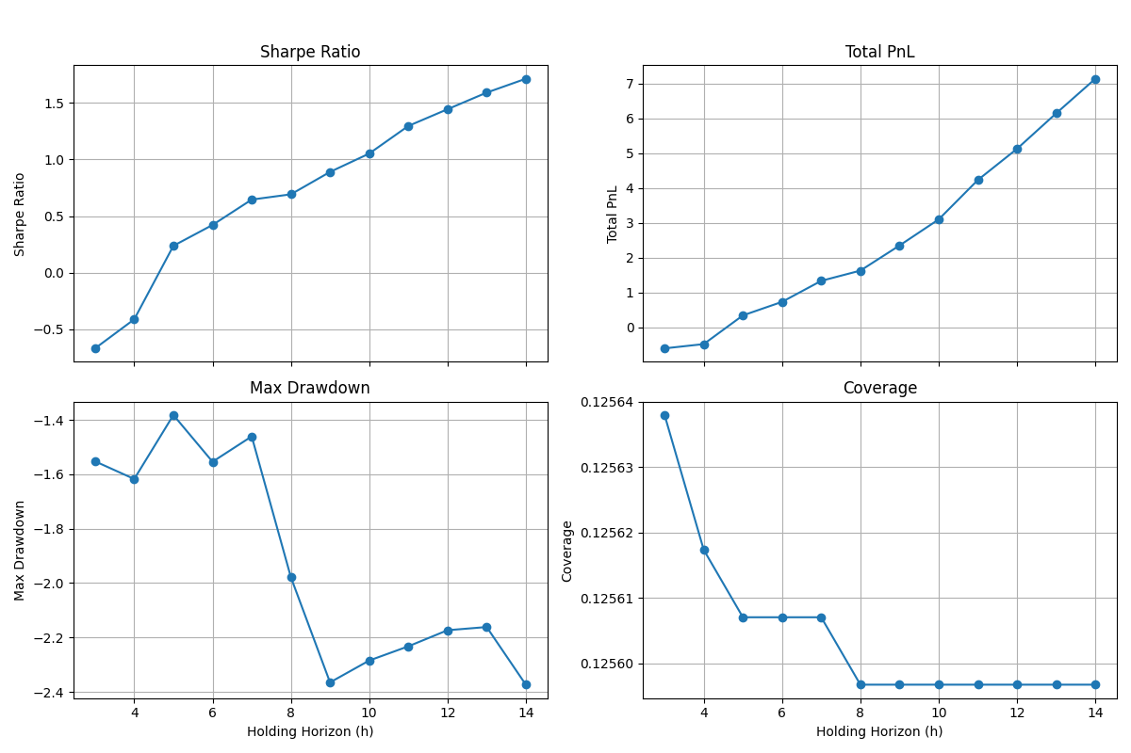
The model should be considered as a probabilistic ranking mechanism, rather than a pure classifier. The selectiveness in choosing predictions which are above a certain threshold sacrifices recall, but in exchange improves per-trade expected returns and risk-adjusted returns. Although classification performance metrics (ROC-AUC ≈ 0.53) indicate marginal improvement from random guessing, economic performance remains positive due to the selectiveness in trading signals. By trading only the upper confidence quantile, the model converts small statistical edges into meaningful economic returns. This highlights the difference between statistical performance measures and real-life tradable signals.
Table 6 reports walk-forward out-of-sample performance metrics across 11 monthly test windows, with a holding period of 10 bars and a transaction cost of $0.0002. The strategy shows a small but persistent positive edge, with a median Sharpe ratio of 0.84 and an average profit factor of just above one. Importantly, the median Sharpe ratio is greater than the mean Sharpe ratio, which shows that the performance is not driven by one lucky period. Also, the drawdowns are contained and do not explode, thus no signs of overfitting. The variation in performance across months indicates sensitivity to market regimes, which is expected for short-horizon predictive models. A small value of the profit factor shows that the profitability matters a lot in transaction costs.

Table 6: Walk-forward out-of-sample Performance
Metrics | Sharpe Ratio | Max Drawdown | Profit Factor | Total PnL | Coverage
Mean | 0.49 | -1.22 | 1.06 | 0.31 | 38.6 %
Median | 0.83 | -1.35 | 1.06 | 0.56 | 39.4 %
Standard Deviation | 2.1 | 0.64 | 0.2 | 1.38 | 5 %

- Conclusion
To tackle the various limitations of detached econometric and machine learning models, a hybrid model is proposed. This model combines the power of econometric models, ARMA and GARCH, with the machine learning techniques. The econometric model ARMA is used to capture the linear trends in the data, whereas the GARCH model is used to forecast volatility. The machine learning model used is an XGBoost Classifier. This is used to predict the final change in price. Other than the results of ARMA and GARCH, various calculated technical indicators were also given as input to the XGBoost regressor. Various technical indicators like RSI and MACD have proven to be capable of predicting the stock market trend. Based on the stock price data of 5 stocks, from the NYSE, covering 1004 days, at 5-minute intervals, various evaluation metrics were calculated, and comparison graphs were drawn between the actual and predicted prices.
In comparison to the earlier methods, the proposed framework has the following advantages:
- Incorporates multiple technical tools to get a complete overview of the price dynamics
- The model performs significantly better than the individual econometric or XGBoost model
- Trading profitability is also measured to test its capabilities in real-life conditions.
Implications of the study
The results of this model confirm that combining various technical indicators can lead to a machine learning model capable of predicting the stock market performance more accurately. This finding encourages future research to move beyond standalone models and adopt integrated frameworks for handling complex, noisy financial time-series data.
Limitations and Scope for Future Work
The study has several limitations which must be considered. First, the analysis is confined to only 5 stocks of the NYSE. Therefore, the model’s performance may differ when applied to other markets, such as emerging markets or other stock exchanges. Second, despite the use of regularization in XGBoost, the inclusion of various correlated technical indicators introduces the risk of overfitting.
In the future, the accuracy of the predictions can be further improved by using a much bigger dataset, with more diverse technical indicators. Furthermore, more advanced machine learning models like LSTM and Neural Networks can be applied.
References
Ampomah, E. K., Qin, Z., & Nyame, G. (2020). Evaluation of tree-based ensemble machine learning models in predicting stock price direction of movement. Information (Switzerland), 11(6). https://doi.org/10.3390/info11060332
Bao, W., Cao, Y., Yang, Y., Che, H., Huang, J., & Wen, S. (2025). Data-driven stock forecasting models based on neural networks: A review. Information Fusion, 113, 102616. https://doi.org/https://doi.org/10.1016/j.inffus.2024.102616
Celestin, M., Vasuki, M., Dinesh Kumar, A., & Johnson Asamoah, P. (2025). Applications of GARCH Models for Volatility Forecasting in High-Frequency Trading Environments. International Journal of Applied and Advanced Scientific Research (IJAASR) International Peer Reviewed-Refereed Research Journal, 655(1), 2456–3080. https://doi.org/10.5281/zenodo.14904200
ChaoYan Wei*, LanLan Li, PangLeYi Chen, MeiHui Huang, HuiLin Wei, KunYao Yao, XuYang Wang, Xin Ya, & ChaoHai Wei. (2025). STOCK PRICE RESEARCH BASED ON ARIMA-GARCH-LSTM HYBRID MODEL. Journal of Trends in Financial and Economics, 2(2). https://doi.org/10.61784/jtfe3043
Deng, C., Zhang, X., Li, Y., & Xiong, Q. (2020). Garch model test using high-frequency data. Mathematics, 8(11), 1–17. https://doi.org/10.3390/math8111922
Egeli, B., Ozturan, M., & Badur, B. (2003). Stock Market Prediction Using Artificial Neural Networks Stock Market Prediction Using Artificial Neural Networks. Proceedings of the 3rd International Conference on Business.
Gu, Y., Yan, D., Yan, S., & Jiang, Z. (2020). Price Forecast with High-Frequency Finance Data: An Autoregressive Recurrent Neural Network Model with Technical Indicators. International Conference on Information and Knowledge Management, Proceedings, 2485–2492. https://doi.org/10.1145/3340531.3412738
Kah Him, C., & Ching Pang, G. (2023). Stock Trend Prediction Using LSTM with MA, EMA, MACD and RSI Indicators. INTI JOURNAL, 2023(67), 67–2600.
Khaidem, L., Saha, S., & Dey, S. R. (2016). Predicting the direction of stock market prices using random forest. http://arxiv.org/abs/1605.00003
Kim, K. (2003). Financial time series forecasting using support vector machines. Neurocomputing, 55(1), 307–319. https://doi.org/https://doi.org/10.1016/S0925-2312(03)00372-2
Krishnan, R. (2010). ANALYSING HIGH FREQUENCY DATA USING ARCH AND GARCH METHODS SINGAPORE MANAGEMENT UNIVERSITY 2010. http://ssrn.com/abstract=1611531https://ssrn.com/abstract=1611531Electroniccopyavailableat:http://ssrn.com/abstract=1611531
Lanbouri, Z., & Achchab, S. (2020a). Stock market prediction on high frequency data using long-short term memory. Procedia Computer Science, 175, 603–608. https://doi.org/10.1016/j.procs.2020.07.087
Lanbouri, Z., & Achchab, S. (2020b). Stock market prediction on high frequency data using long-short term memory. Procedia Computer Science, 175, 603–608. https://doi.org/10.1016/j.procs.2020.07.087
López De Prado, M. (2019). BEYOND ECONOMETRICS: A ROADMAP TOWARDS FINANCIAL MACHINE LEARNING. https://ssrn.com/abstract=3365282
Mintarya, L. N., Halim, J. N. M., Angie, C., Achmad, S., & Kurniawan, A. (2023). Machine learning approaches in stock market prediction: A systematic literature review. Procedia Computer Science, 216, 96–102. https://doi.org/https://doi.org/10.1016/j.procs.2022.12.115
Ni, Z., & Chen, W. (2022). A Comparative Analysis of the Application of Machine Learning Algorithms and Econometric Models in Stock Market Prediction. In BCP Business & Management MEEA (Vol. 2022).
Shah, D., Isah, H., & Zulkernine, F. (2019). Stock market analysis: A review and taxonomy of prediction techniques. In International Journal of Financial Studies (Vol. 7, Number 2). MDPI Multidisciplinary Digital Publishing Institute. https://doi.org/10.3390/ijfs7020026
Stempień, D., & Ślepaczuk, R. (2025). Hybrid Models for Financial Forecasting: Combining Econometric, Machine Learning, and Deep Learning Models. http://arxiv.org/abs/2505.19617
Su, H., Wang, X., Qin, Y., & Chen, Q. (2024). Attention based adaptive spatial–temporal hypergraph convolutional networks for stock price trend prediction. Expert Systems with Applications, 238, 121899. https://doi.org/https://doi.org/10.1016/j.eswa.2023.121899
William, Wilham, A. K., & Manalu, S. R. (2025). Stocks and models: A comparative benchmark of machine learning and deep learning approaches for stock market prediction. Procedia Computer Science, 269, 1532–1545. https://doi.org/10.1016/j.procs.2025.09.095
Xu, J., He, J., Gu, J., Wu, H., Wang, L., Zhu, Y., Wang, T., He, X., & Zhou, Z. (2022). Financial Time Series Prediction Based on XGBoost and Generative Adversarial Networks. International Journal of Circuits, Systems and Signal Processing, 16, 637–645. https://doi.org/10.46300/9106.2022.16.79
Yang, J., Wang, Y., & Li, X. (2022). Prediction of stock price direction using the LASSO-LSTM model combines technical indicators and financial sentiment analysis. PeerJ Computer Science, 8, e1148. https://doi.org/10.7717/peerj-cs.1148
Zhang, Y.-J., & Wang, J.-L. (2019). Do high-frequency stock market data help forecast crude oil prices? Evidence from the MIDAS models. Energy Economics, 78, 192–201. https://doi.org/https://doi.org/10.1016/j.eneco.2018.11.015
Zhou, X., Pan, Z., Hu, G., Tang, S., & Zhao, C. (2018). Stock Market Prediction on High-Frequency Data Using Generative Adversarial Nets. Mathematical Problems in Engineering, 2018(1), 4907423. https://doi.org/https://doi.org/10.1155/2018/4907423

